For our game one of the concepts was to set the tug of war in a pond set between ducks.
Further exploring the theme we played with the idea of the game taking place in space with ducks floating on water over Earth.
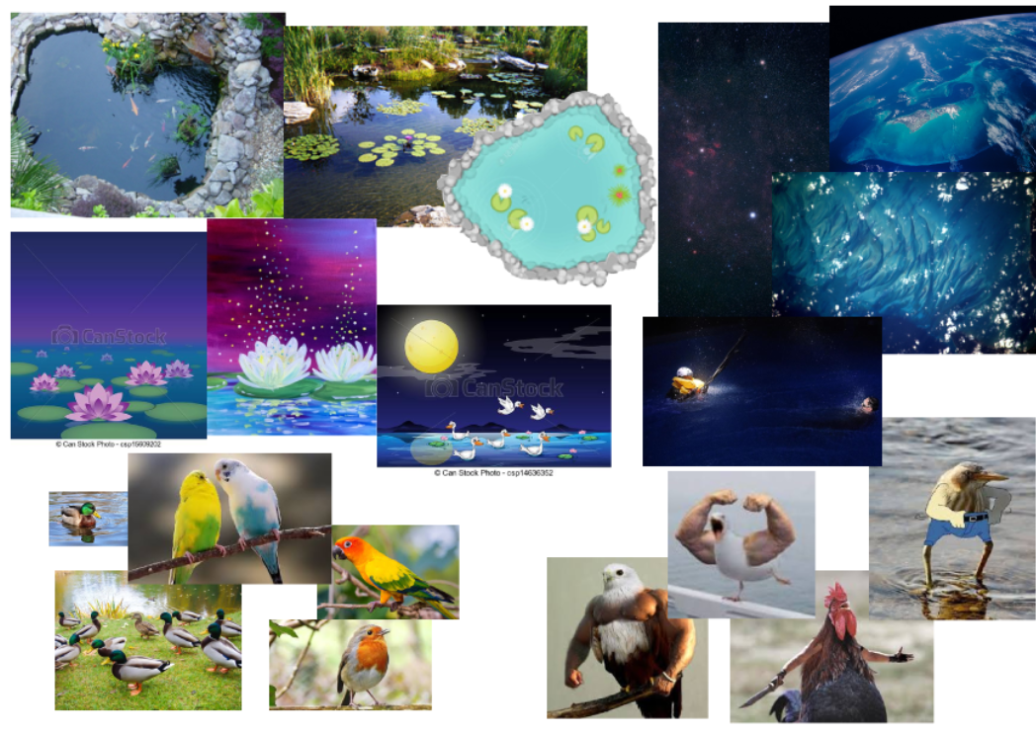

Looking at colour and various art styles for the game concept. Using bright and clear colours to clearly describe the setting.
Looking at a range of birds as the playable characters.
Taking a comical shift to the theme we found birds with human appendages to be both humorous and practical to our game design.
Birds would use these arms for the push or pull mechanic in the game.

